
Sukkur IBA University
Department of Computer Science
ESE-201: Digital Logic Design Lab

Lab # 10: S-R Latch
Instructor: Muhammad Ismail Qureshi
Submission Profile
Name: Ghulam Mustafa Submission date 25/12/2025
CMS ID: 023-24-0513 Marks obtained:
Comments: Receiving authority name and signature:

________________________________________________________________________________
Instructor Signature

Note: Submit this lab hand-out on LMS/e-learning before the next lab with attached solved activities and exercises.

Lab Learning Objectives:

Upon successful completion of this experiment, the student will be able:
- To implement and verify S-R latch operations using two NOR or two NAND gates & NI ELVIS II Kit

Lab Hardware and Software Required:
- 74LS02 IC
- 74LS00 IC
- NI ELVIS II Kit
- Breadboard
- Connecting Wires

Background Theory:

Bi-stable Multivibrator:
The bi-stable multivibrators commonly called latches or latchs, are the most common form of digital memory elements. A memory element is generally a device which can store the logic state 0 or 1, called information bit. The most basic latch circuit can be constructed from either two NOR gates or two NAND gates.
Using NOR Gates:
A main memory circuit can be carried out with the crossed coupling of two NOR gates, this type of connection is S-R latch as shown in Fig 10.1 (a & b). The two NOR gates are cross coupled so that the output of NOR 1 gate is connected to one of the inputs of the NOR 2 gate and vice versa. The gates outputs Q and Q’ respectively, are latch’s outputs. Under the normal conditions, these outputs will always be the inverse of each other. There are two latch inputs: the set input (S) is the input that sets Q to the 1 state; the reset input (R) is the input that resets Q to the 0 state.
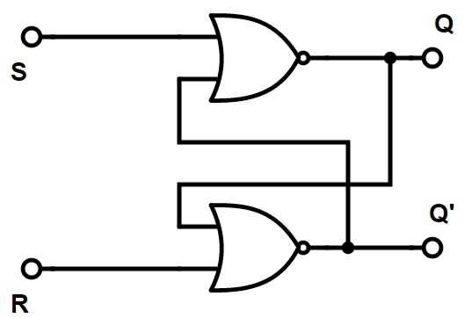
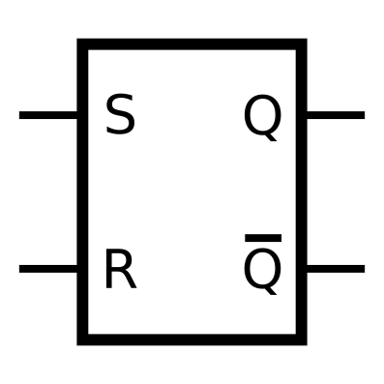

Fig 10.1: (a) Simplified block diagram of S-R latch (b) NOR gate S-R latch
Suppose a data is to be inserted into the latch, the input levels are S=R=0. This is the normal resting state for the latch, and it has no effect on the output states. Q and will remain in whatever state they were prior to the occurrence of this input condition. When S=1 and R=0, this will always set Q=1, where it will remain even after set returns to 0. S=0 and R=1 will always reset Q=0, where it will remain even after set returns to 0. S=R=1 condition tries to set and reset the latch at the same time, and it produces Q= =0. If the inputs are returned to 0 simultaneously, the resulting output state is unpredictable. This input condition should not be used.
Using NAND Gates:
Two cross coupled NAND gates can be used to construct a NAND gate latch as shown in Fig: 10.2 (a & b). The arrangement 10.2 (b) is similar to NOR gate latch except that the Q and outputs have reversed positions.
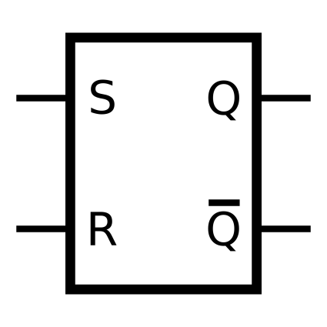
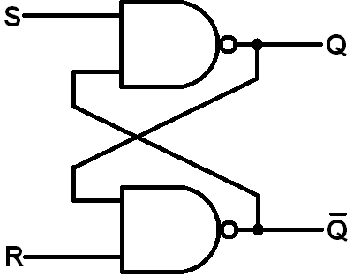

Fig 10.2: (a) Simplified block diagram of S-R-latch (b) NAND gate latch
The analysis and the operation of the NAND gate latch can be performed is exactly the same manner as used for the NOR gate latch.

Lab Examples:
Implementation of S-R latch using NOR gates:
- Carry out the circuits of Fig 10.1 by using IC of NOR gates
- Make the circuit on breadboard present on the NI ELVIS-II kit
- Apply power supply to it
- Connect the inputs S and R of both circuits to the switches
- Connect the outputs Q and Q-of both circuits to the LEDs
- Analyze the circuit’s behaviour by carrying out different combinations with the switches and fill the observation tables
Table 10.1: Observation table of S-R latch using NOR gates
Inputs |  | Outputs
S | R | Q | $$\overline{Q}$$
0 | 0 | 0 | 1
0 | 1 | 1 | 0
1 | 0 | 0 | 1
1 | 1 | 0 | 0

Lab Activities:
Implementation of S-R latch using NAND gates:
- Carry out the circuits of Fig 10.2 by using IC of NAND gates
- Make the circuit on breadboard present on the NI ELVIS-II kit
- Apply power supply to it
- Connect the inputs S and R of both circuits to the switches
- Connect the outputs Q and Q-of both circuits to the LEDs
- Analyze the circuit’s behaviour by carrying out different combinations with the switches and fill the observation tables
Table 10.2: Observation table of SR latch using NAND gates
Inputs |  | Outputs
S | R | Q | $$\overline{Q}$$
0 | 0 | On | On
0 | 1 | Off | On
1 | 0 | On | Off
1 | 1 | On | On

Lab Exercises:
Implement S-R latch circuit in Multisim, attach circuit diagrams showing set and reset states.

